Assignment 4 - Date 2023-04-04

Group 4

Sanjeev Bindukar - 200505358

Sakchhyat Bhandari - 200495842

Mohit Mohit - 200456051

Saurav Prasai - 200495782

***********************************************************************

Question No 1

BACKUP DATABASE AdventureWorks2019

TO DISK = 'F:\AdventureWorks2019.bak';

DROP DATABASE AdventureWorks2019;

RESTORE DATABASE AdventureWorks2019 FROM DISK = 'F:\AdventureWorks2019.bak';

SELECT FirstName, LastName

FROM Person.Person

WHERE FirstName LIKE 'Amb%' AND MiddleName IS NULL;

Processed 26392 pages for database 'AdventureWorks2019', file 'AdventureWorks2017' on file 5.

Processed 2 pages for database 'AdventureWorks2019', file 'AdventureWorks2017_log' on file 5.

BACKUP DATABASE successfully processed 26394 pages in 0.283 seconds (728.619 MB/sec).

Processed 26392 pages for database 'AdventureWorks2019', file 'AdventureWorks2017' on file 1.

Processed 2 pages for database 'AdventureWorks2019', file 'AdventureWorks2017_log' on file 1.

RESTORE DATABASE successfully processed 26394 pages in 0.341 seconds (604.689 MB/sec).

FirstName LastName

-------------------------------------------------- --------------------------------------------------

Amber Adams

Amber Baker

Amber Campbell

Amber Evans

Amber Green

Amber Hall

Amber Hernandez

Amber Lopez

Amber Parker

Amber Phillips

Amber Turner

(11 rows affected)

Question no 2

UPDATE Person.Person

SET Title = 'Mr.', ModifiedDate = '1990-01-01'

WHERE FirstName = 'Amy' AND LastName = 'Alberts' AND Title IS NULL;

(2 rows affected)

Question no 3

SELECT TOP 10 p.FirstName, p.LastName, p.Title, be.BusinessEntityID, bea.AddressID

FROM Person.Person p INNER JOIN Person.BusinessEntity be

ON p.BusinessEntityID = be.BusinessEntityID INNER JOIN Person.BusinessEntityAddress bea

ON be.BusinessEntityID = bea.BusinessEntityID;

FirstName LastName Title BusinessEntityID AddressID

-------------------------------------------------- -------------------------------------------------- -------- ---------------- -----------

Suchitra Mohan NULL 34 184

Brandon Heidepriem NULL 35 212

Jose Lugo NULL 36 100

Chris Okelberry NULL 37 227

Kim Abercrombie NULL 38 90

Ed Dudenhoefer NULL 39 93

JoLynn Dobney NULL 40 92

Bryan Baker NULL 41 69

James Kramer NULL 42 67

Nancy Anderson NULL 43 197

(10 rows affected)

Question no 4 :Created a database diagram for A and B­­­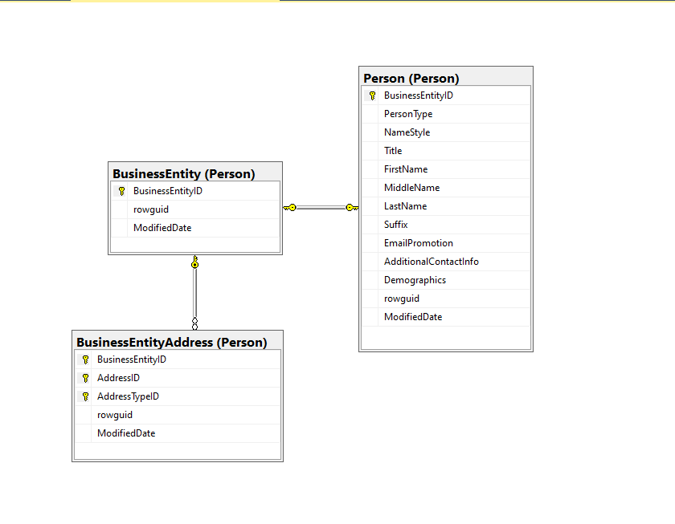

Diagram for Question A

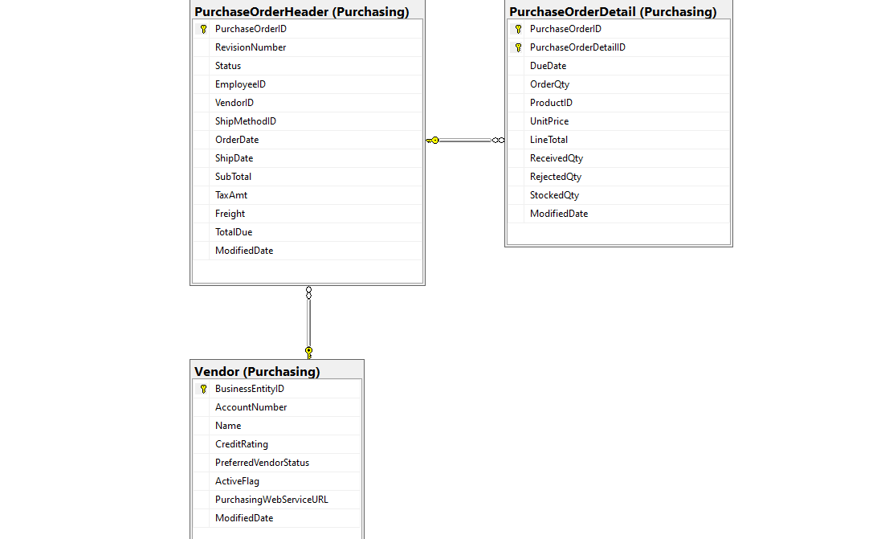

Diagram for Question B

Question no 5

USE AdventureWorks2019;

GO

CREATE VIEW PurchaseOrderInformation AS

SELECT pod.OrderQty, pod.UnitPrice, pod.PurchaseOrderID, poh.OrderDate, poh.VendorID

FROM Purchasing.PurchaseOrderDetail pod

INNER JOIN Purchasing.PurchaseOrderHeader poh

ON pod.PurchaseOrderID = poh.PurchaseOrderID;

GO

OrderQty UnitPrice PurchaseOrderID OrderDate VendorID

-------- --------------------- --------------- ----------------------- -----------

4 50.26 1 2011-04-16 00:00:00.000 1580

3 45.12 2 2011-04-16 00:00:00.000 1496

3 45.5805 2 2011-04-16 00:00:00.000 1496

550 16.086 3 2011-04-16 00:00:00.000 1494

3 57.0255 4 2011-04-16 00:00:00.000 1650

550 37.086 5 2011-04-30 00:00:00.000 1654

550 26.5965 6 2011-04-30 00:00:00.000 1664

550 27.0585 7 2011-04-30 00:00:00.000 1678

550 33.579 7 2011-04-30 00:00:00.000 1678

550 46.0635 7 2011-04-30 00:00:00.000 1678

(10 rows affected)

Question no 6

GO

CREATE TRIGGER SQLTrigger ON Purchasing.PurchaseOrderDetail

FOR UPDATE

AS

BEGIN

DECLARE @updateDate DATETIME

SET @updateDate = GETDATE()

PRINT 'A row has been updated on ' + CONVERT(VARCHAR(20), @updateDate)

END

UPDATE Purchasing.PurchaseOrderDetail

SET ModifiedDate = GETDATE();

GO

Question no 7

SELECT TOP 10 p.FirstName, p.LastName, sp.SalesYTD, sp.SalesLastYear,

sp.SalesYTD - sp.SalesLastYear AS Compare,

CASE

WHEN sp.SalesLastYear < sp.SalesYTD THEN 'Need more bonus'

ELSE 'No bonus'

END AS Bonus

FROM Sales.SalesPerson sp

INNER JOIN Person.Person p ON sp.BusinessEntityID = p.BusinessEntityID

ORDER BY p.LastName;

FirstName LastName SalesYTD SalesLastYear Compare Bonus

-------------------------------------------------- -------------------------------------------------- --------------------- --------------------- --------------------- ---------------

Syed Abbas 172524.4512 0.00 172524.4512 Need more bonus

Amy Alberts 519905.932 0.00 519905.932 Need more bonus

Pamela Ansman-Wolfe 1352577.1325 1927059.178 -574482.0455 No bonus

Michael Blythe 3763178.1787 1750406.4785 2012771.7002 Need more bonus

David Campbell 1573012.9383 1371635.3158 201377.6225 Need more bonus

Jillian Carson 3189418.3662 1997186.2037 1192232.1625 Need more bonus

Shu Ito 2458535.6169 2073505.9999 385029.617 Need more bonus

Stephen Jiang 559697.5639 0.00 559697.5639 Need more bonus

Tete Mensa-Annan 1576562.1966 0.00 1576562.1966 Need more bonus

Linda Mitchell 4251368.5497 1439156.0291 2812212.5206 Need more bonus

(10 rows affected)

Completion time: 2023-04-07T16:57:14.5378464-04:00